**Create a simple cloud software application for Car Booking Reservation System using any Cloud Service Provider to demonstrate SaaS include the necessary fields such as search for cabs, from, to, rental, out station, Package type, hours/Days etc.**

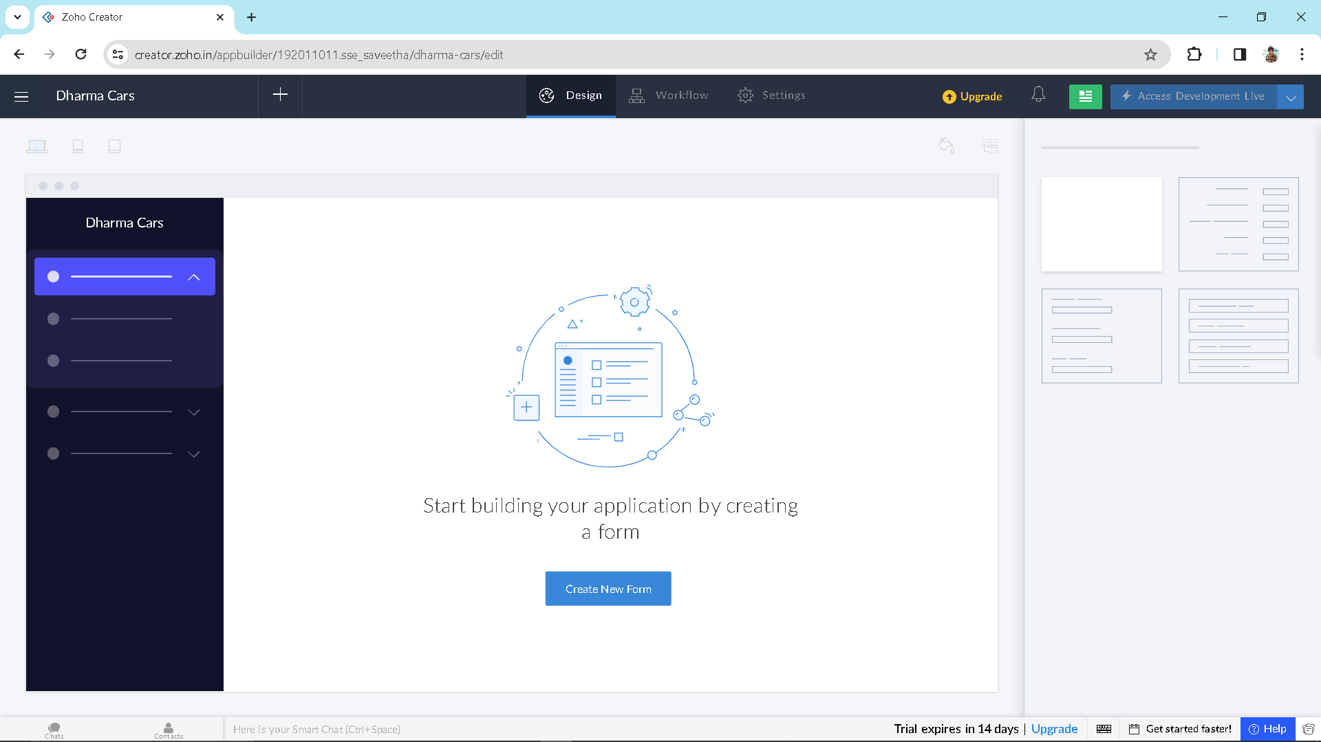

Step1: Open creator application

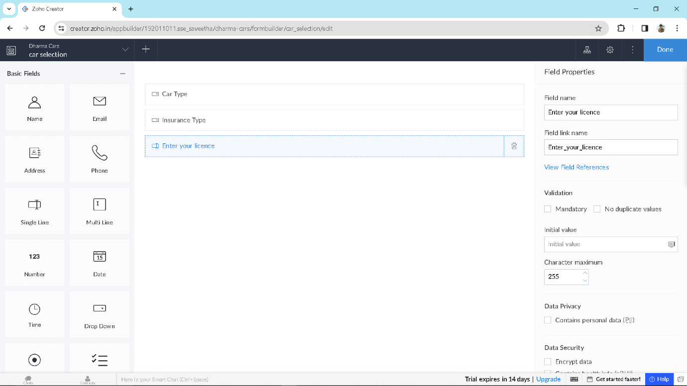Step 2: Create form car selection

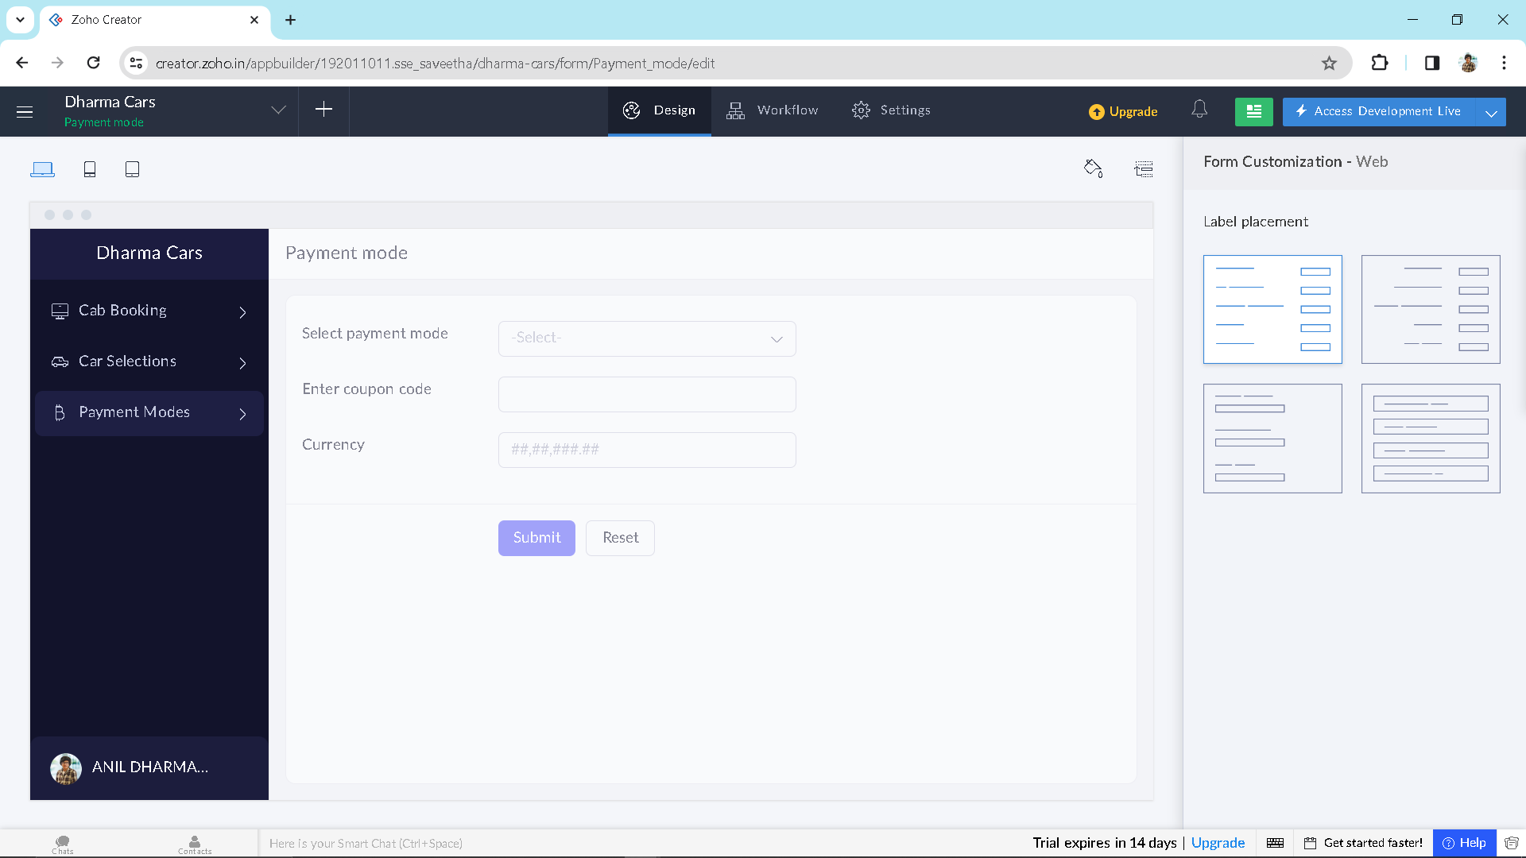

Step 3: create required forms for application

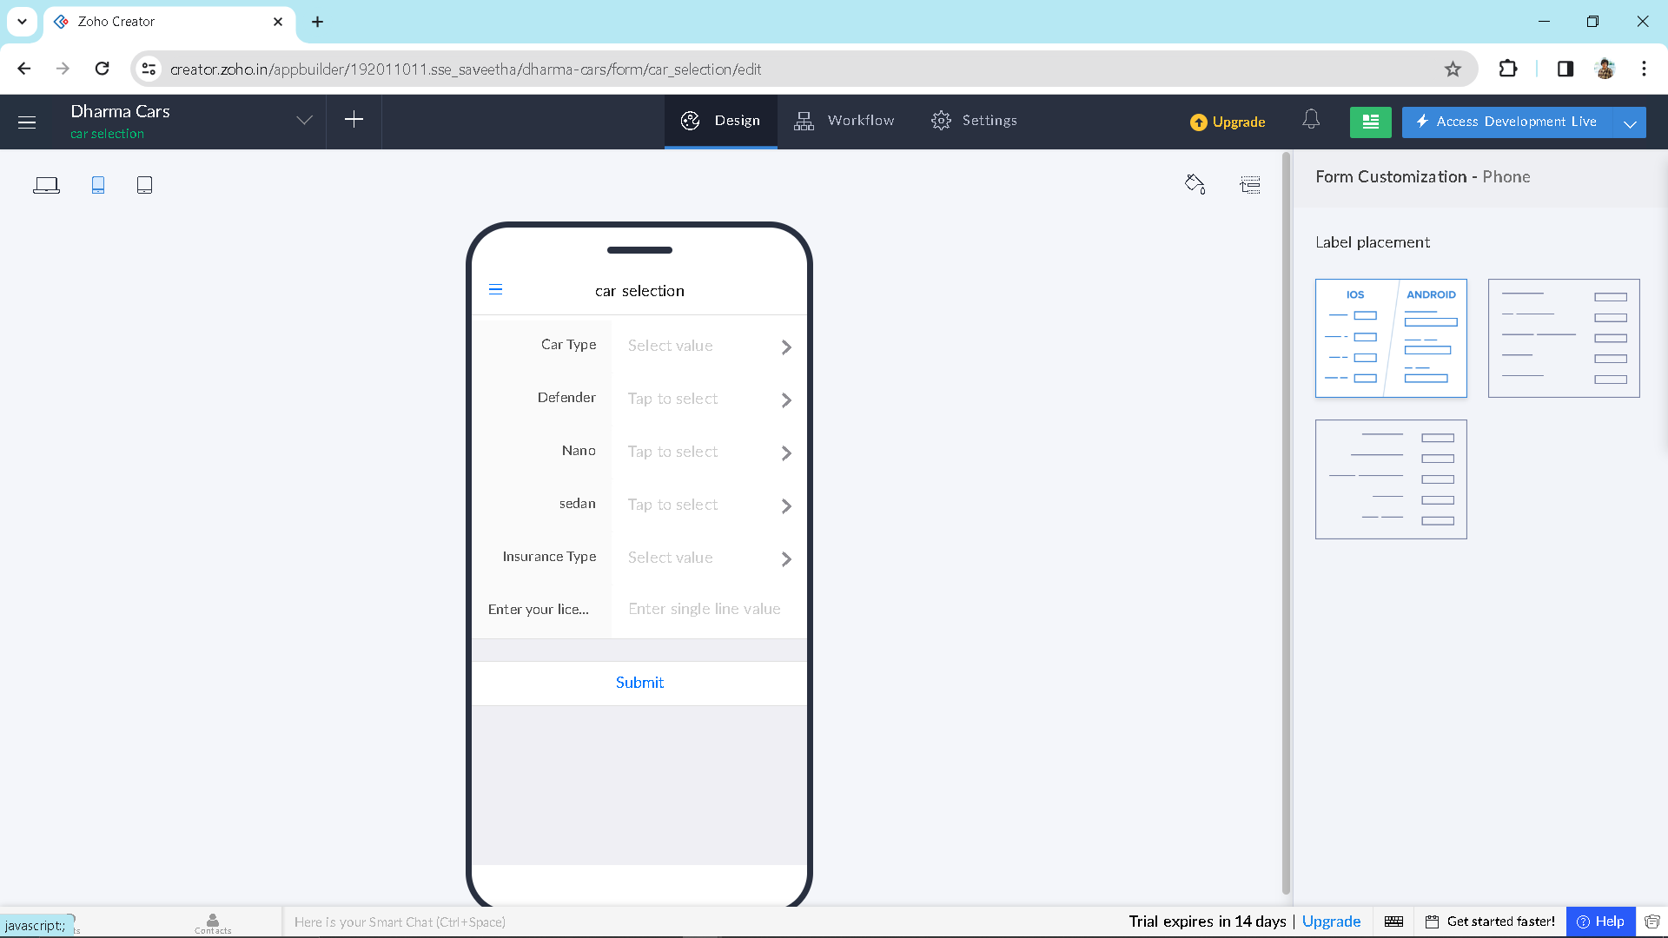

Step 4: Output for Car selection

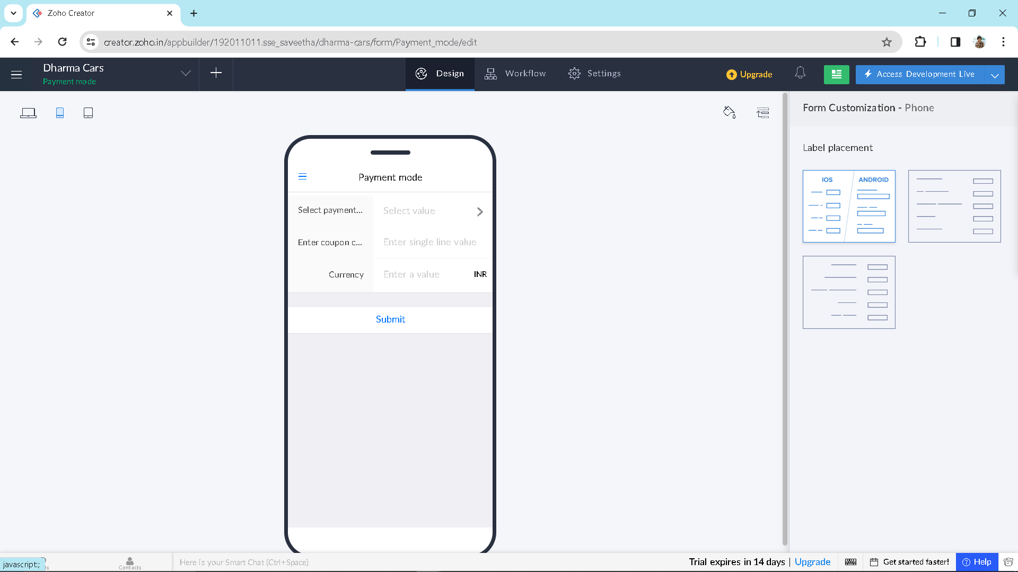

Step 5: output for payment mode